**Report For Mobile**

* Usability

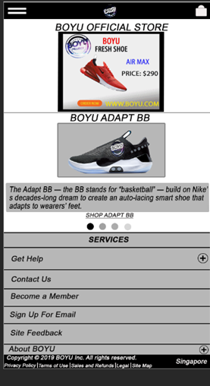My Webpage is easy to use because it has a Menu bar, Cart bar for the visitor to navigate does not have unnecessary text on the page which made it easier to read and also the content is well organized.

* Accessibility

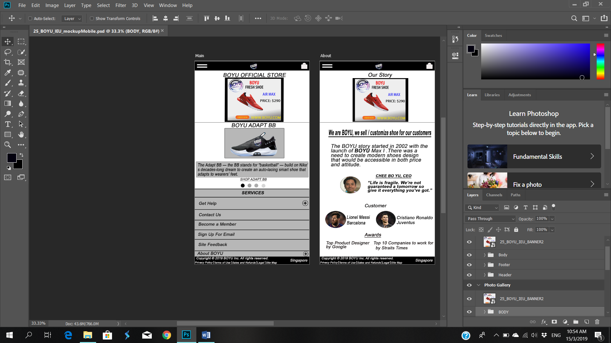My Webpage uses the same font and button for the visitor to navigate my webpage, offer choice such as Filter, Get Help, Contact Us, Become a member, Sign up for email, Site feedback, About Boyufor the visitor to what they want or choose for their preference.

* Consistency

The banner, header and footer have appeared in the same position throughout the webpage. The textual elements are evenly aligned and the font type is the same throughout. The colour is consistent throughout the page. The Cart bar has the same spot throughout the website and it is easier for the customer to find.

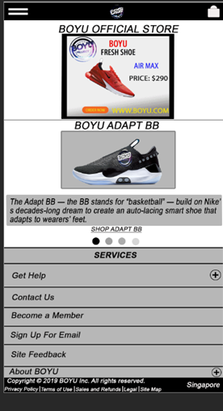

* Predictable

I use simple and basic interaction for the webpage so that user will know how to navigate the webpage, example Shopping Cart for the customer to bookmark their product and Menu Bar for the customer to chose what categories.



* Visibility

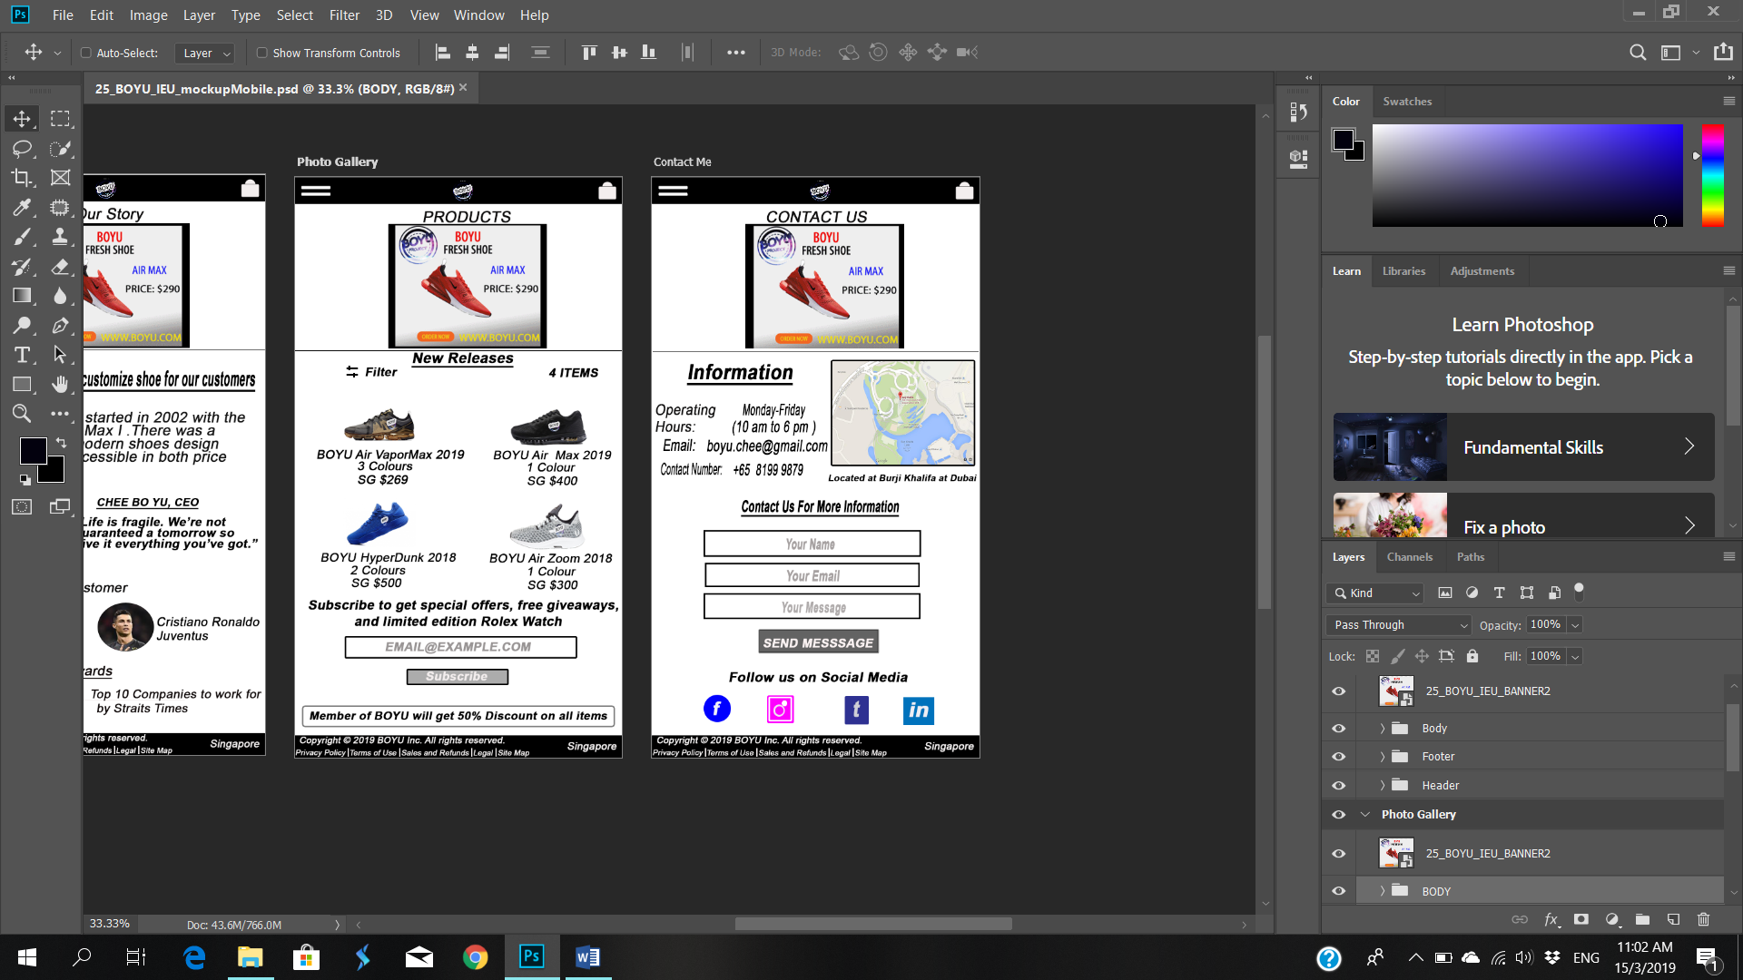My webpage has obvious UL control such as the send the message/ subscribe is visible and accessible for the visitor and social media icons such as Facebook, Instagram, Linkedin and lastly Twitter for the visitor to find out more about the company. There is no hover for touch screen but when the customer click or press will have a hover effect.

* Feedback

My webpage has sent a message for visitor ask a question if they have any enquires, how to improve the webpage design or if there any error on the webpage which is not clickable and also sends message button to be enabled to send a message to me.

